Attack of the Memes Progress

Muhammad
Level Designer

Ashton
Writer, Character Artist

Mamadou
Composer

Thien
Character Artist

Martin
Programmer

Day 1 - 2:

Objective: Player can fight memes to beat game or escape

Concepts for Setting:
Basement (Writer choose this)
Restaurant

Memes (each of us picked):
Muhammad: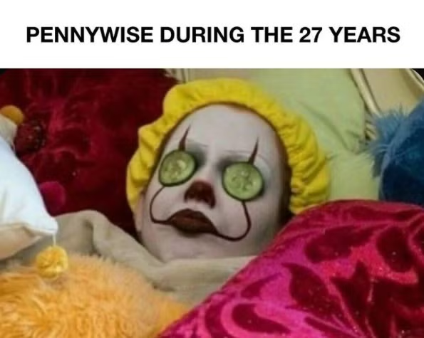 Ashton: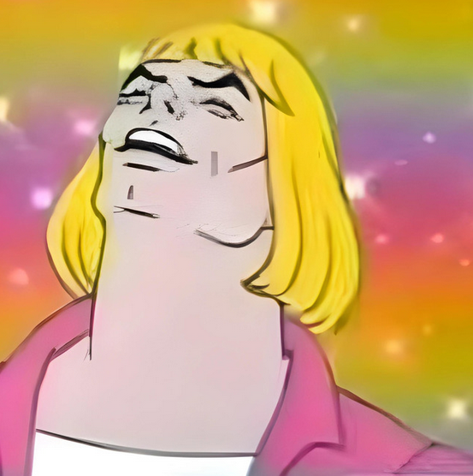 Mamadou: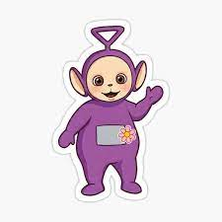

Thien: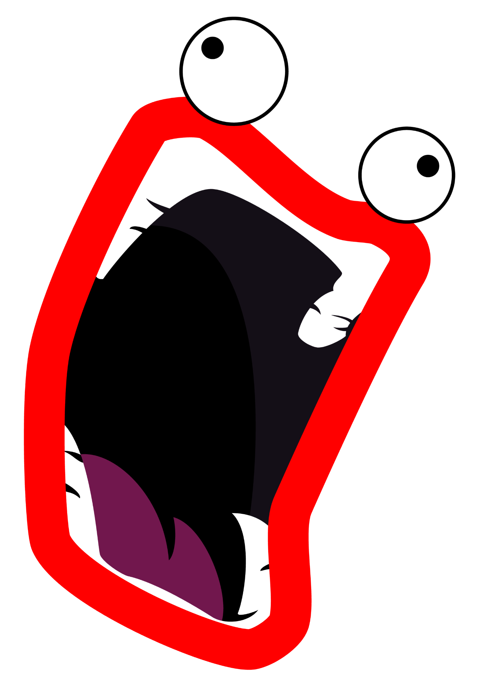 M
Story(written by Ashton): for some reason you are in a basement for reasons you can't remember but you have no time to try to remember things with 5 devilish fools on the rise spa day pennywise , , tinky winky , i'm firin mah lazer guy , Philip J. Fry , he man and he doesn't know what's going on .
artin: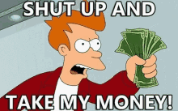

Scrapped Memes (due to copyright):
Thien: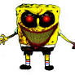 Martin: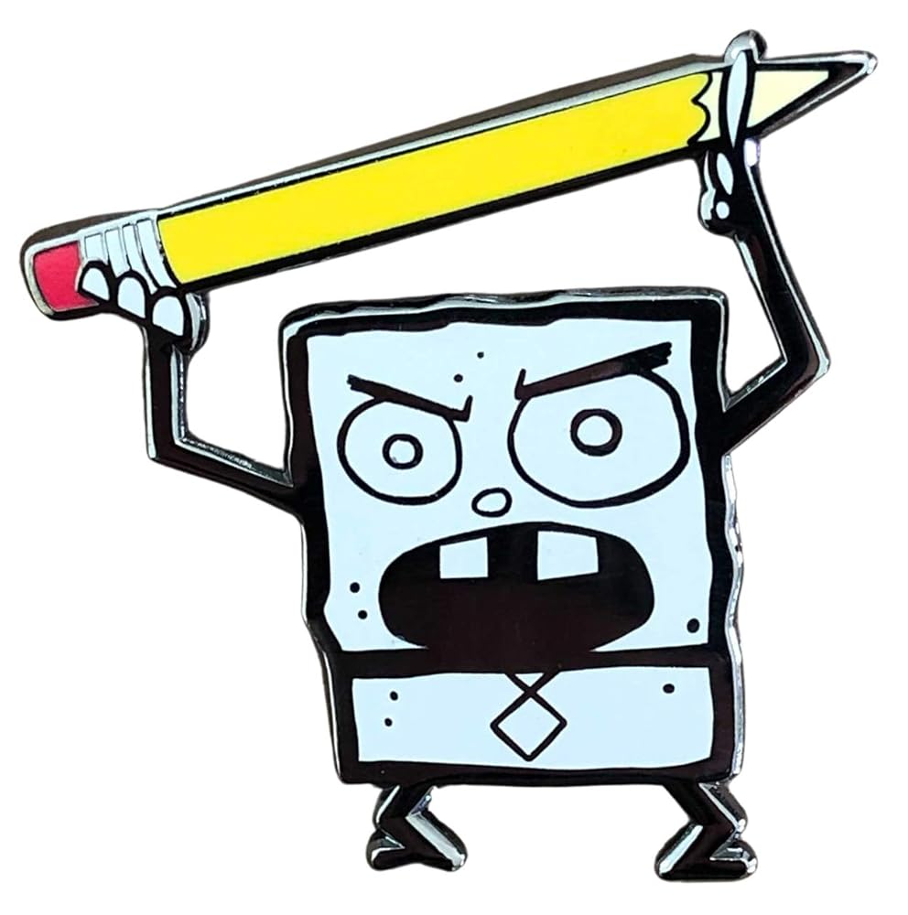

Group Websites (V1):
Group Name and Game Title made by Ashton.
Text color and font made by Muhammd.
Document for the website made by Mamadou.

(Scrapped) Slendybob Redesign - Thien Le:
I took the scrapped mascot of my theater class that I designed.
I choose this as I don’t want the game to get copyrighted by Nickoloden and that my theater class chooses an inappropriate logo over the spongebob logo.
References: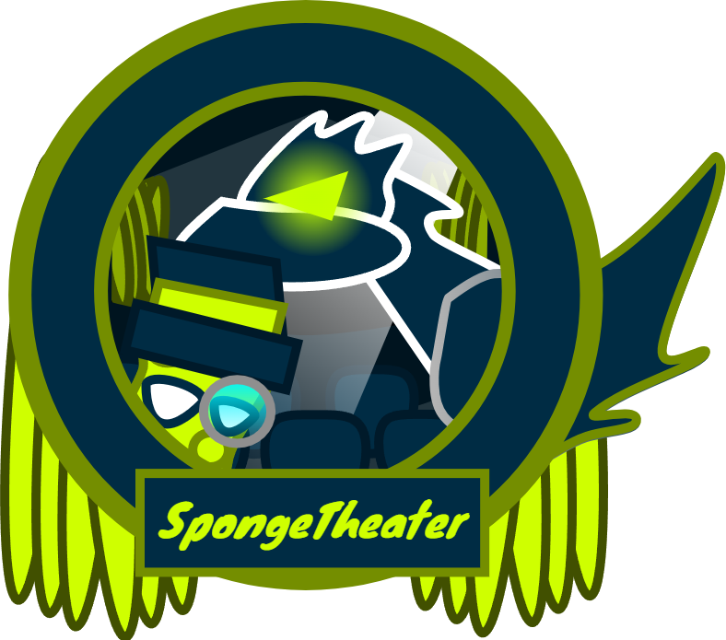

Concept One: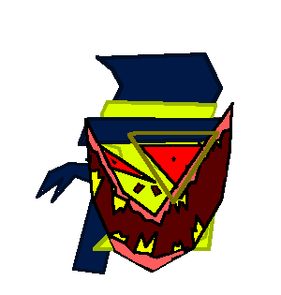

Day 4:

Shoop da Whoop - Thien Le:

References: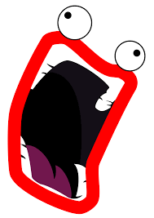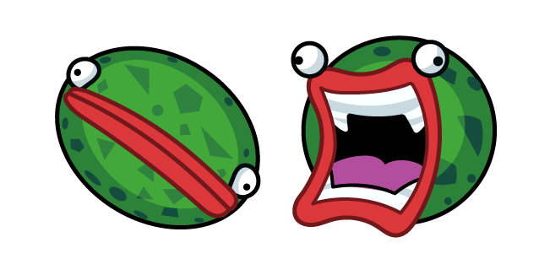

Drawing: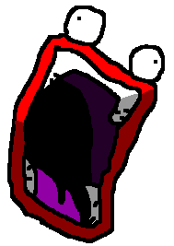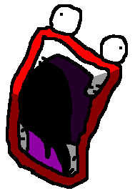

Heman - Ashton:

Reference: 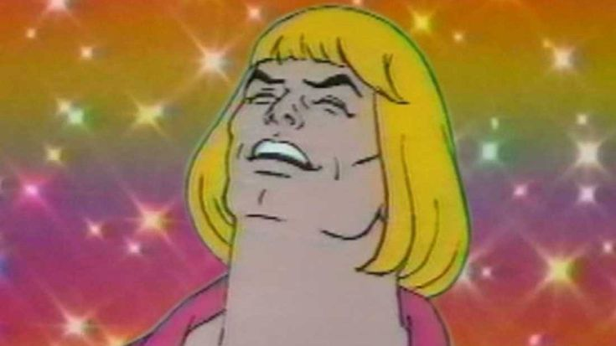

Drawing: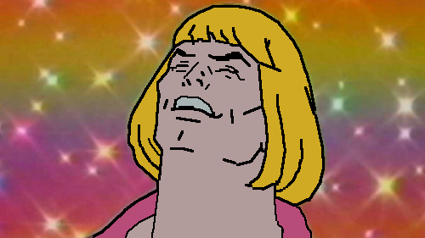

Philip J Fry - Thien Le:

Reference (Front View):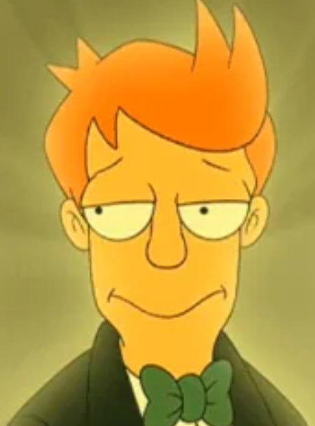
Reference (Body):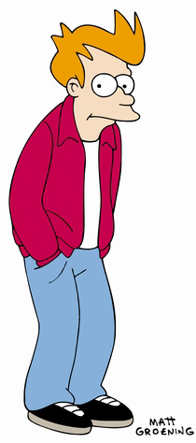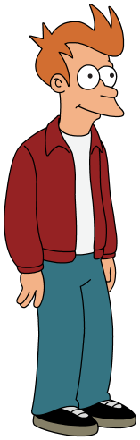

Drawing: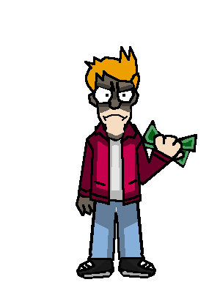

Spa Pennywise - Thien Le:

References: 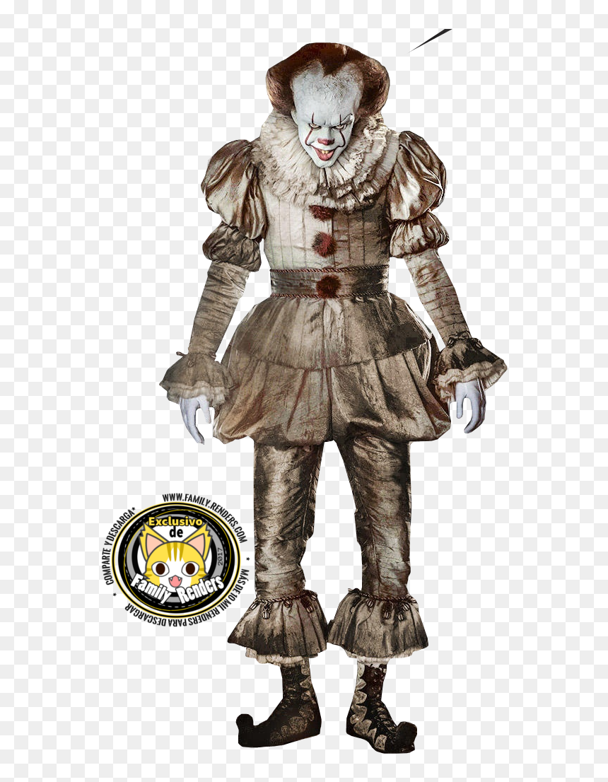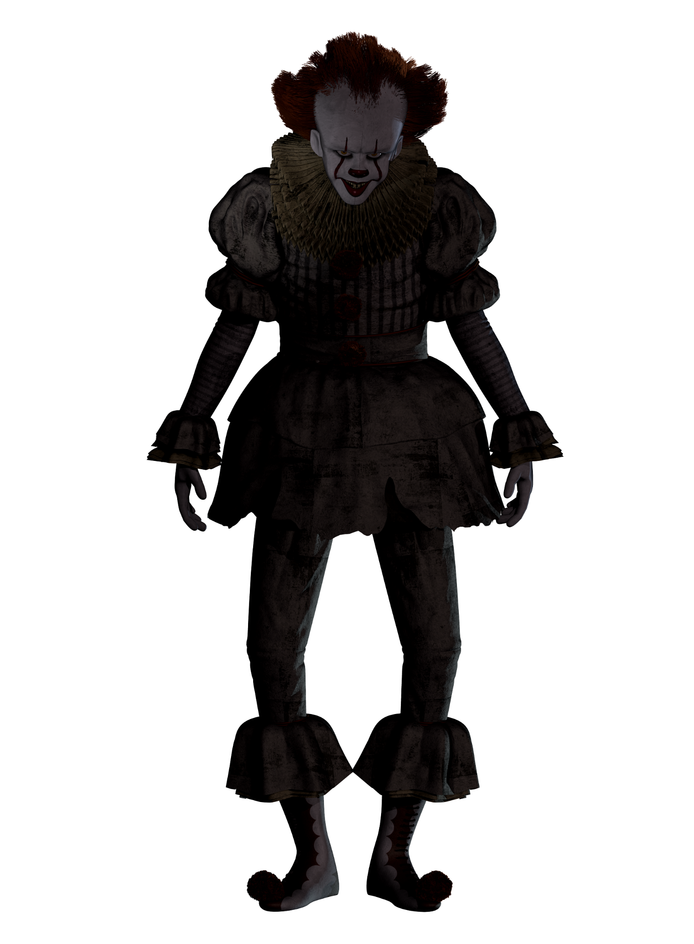

Drawing: 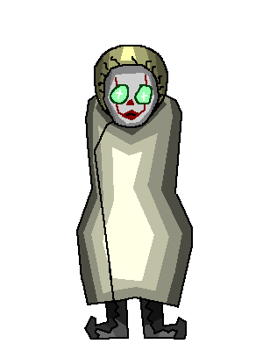

Tinky-Winky - Ashton

References: 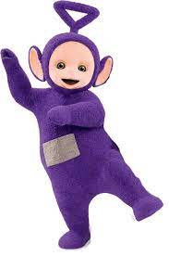

Drawing: 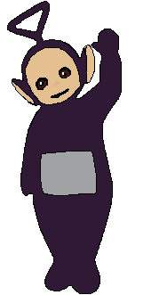

Audio - Mamadou:
Soundtract 1

Soundtrack 2

